**POC - Data Analytics and visualization**

**Availability**

It refers to servers / VM availability showing the up time/downtime in reports showing per minute data periodically.

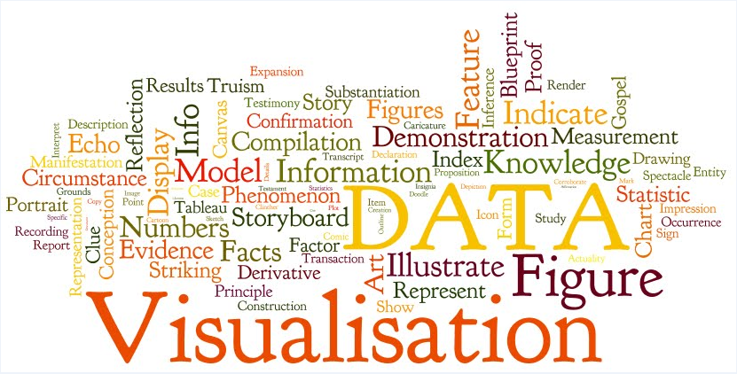

**Service Availability**

***Service*** refers to any group of server or virtual machine or container providing specific functionality. Service availability is an extension of high availability of individual servers/virtual machines/containers, referring to services that are available regardless of hardware/software or user fault.

**Key principles of service availability:**

* Redundancy – "backup" capability in case of need to [failover](https://en.wikipedia.org/wiki/Failover) due to a fault
* [Stateful](https://en.wikipedia.org/wiki/Stateful) and seamless recovery from failures
* Minimization of mean time to repair (MTTR) – time to restore service after an outage
* Fault prediction & avoidance – take action before something fails

There are mainly four types of availability.

1. Virtual Machine / Docket Containers
2. Service Group
3. Service
4. Function / use-case

**Virtual Machine or Docket Containers Availability -** It shall display availability (in %age) and up or down over a selected period

**Service Group Availability -** It shall display service group availability (in %age) over a selected time period.

**Service Availability** - It shall display service availability (in %age) over a selected time period.

**Function / use-case -** It shall display function or use-case availability (in %age) over a selected time.

**Why is it needed?**

It provides below features

1. *Availability reports*
2. *Scalability Analysis reports*
3. *Deployment tracking*
4. *VM Dashboards*
5. *Server monitoring*
6. *Capacity and performance management*
7. *Visual co-relation*

Dashboard will have drill down view from server (Top most layers) to use-cases (bottom layer) availability. User shall be able to create a custom dashboard for a selected report type and able to do quick analysis by visually correlating it with troubleshooting data and executed NMS use cases. User shall be able to take important decisions based on the statistical data provided by function or use-cases availability over a selected period.

**Grafana Dashboard**

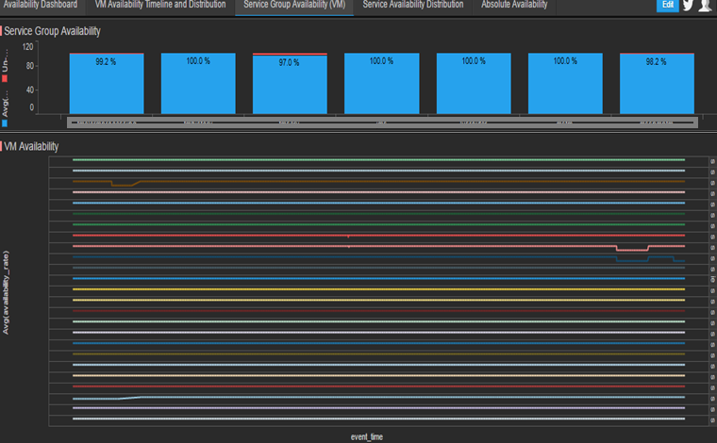

**Tools and Technology used:**

* Grafana
* Any application database ( MySQL)
* Custom SQL scripts for reports